**Assisted Practice: 3.1 Components**

This section will guide you to:

* Create Angular components

This lab has three subsections, namely:

3.1.1 Creating a new project

3.1.2 Creating Angular components

3.1.3 Pushing the code to Github repositories

**Step 3.1.1:** Creating a new project

.

* Angular has been installed in your practice labs using npm (Refer FSD: Lab Guide - Phase 4)
* To verify the installation:
  + Open the command-line interface
  + Type in the command:

*ng --version*

* Create a new project using the command:

*ng new angular-app*

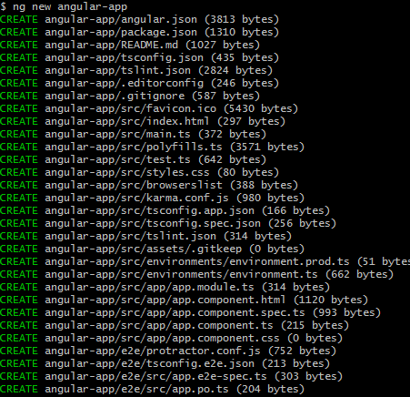

* Move the code to the application folder and start the server.

*cd angular-app*

*ng serve*

**Step 3.1.2:** Creating Angular components

* Open Visual Studio Code
* Navigate to the created angular-app project folder.

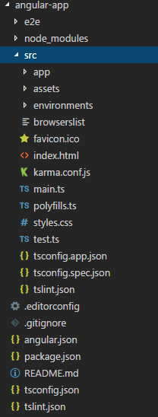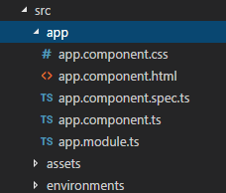

* Add the following code in *app.module.ts*.

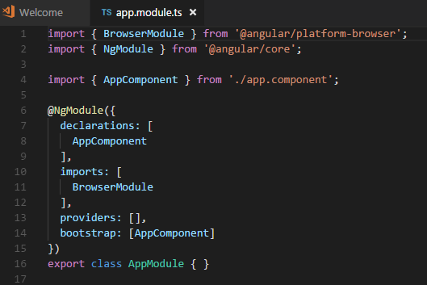

* Create a folder called *products* inside the *src/app* folder.
* Create a *product-list.component.html* file in the *products* folder.
* Add the following code to *product-list.component.html*.

*<h1> Product List Page </h1>*

* Create a file called *product-list.component.ts*.

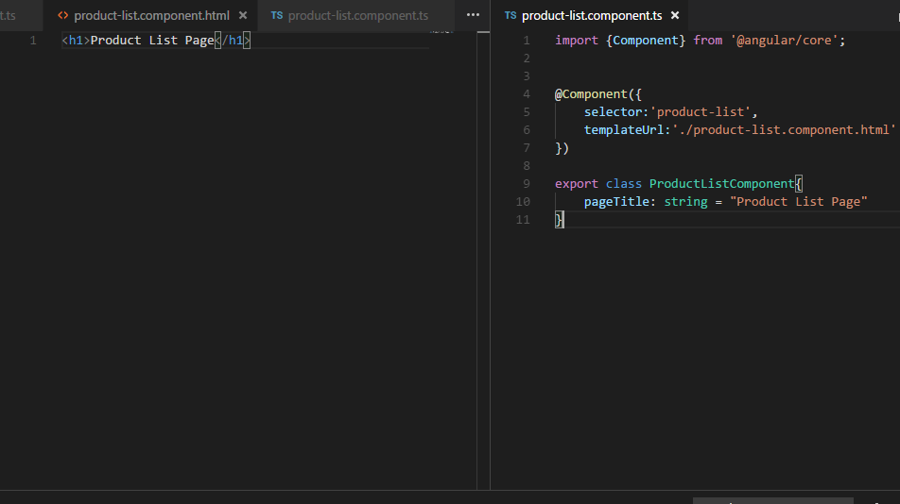

* Add the following code in *app.module.ts*.

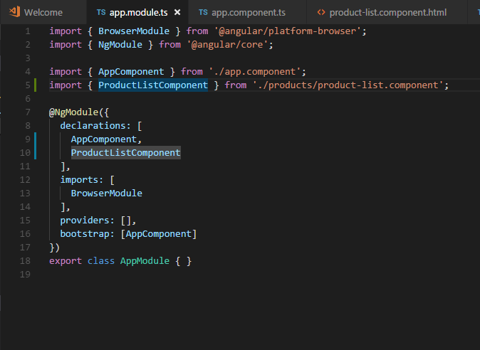

* Add the following code in *app.component.ts*.

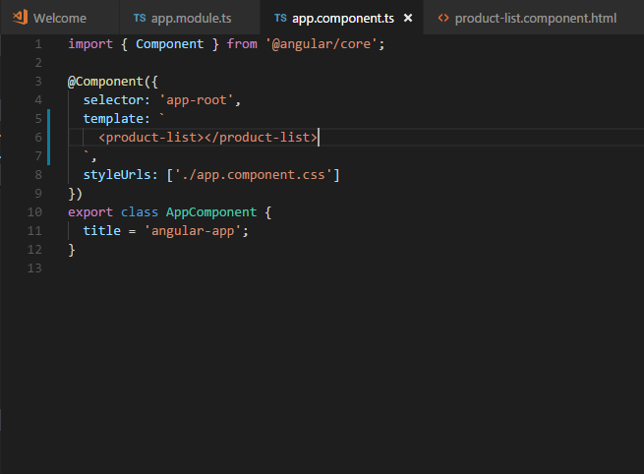

* By saving the above changes and starting the server, you will be able to see the following screen:

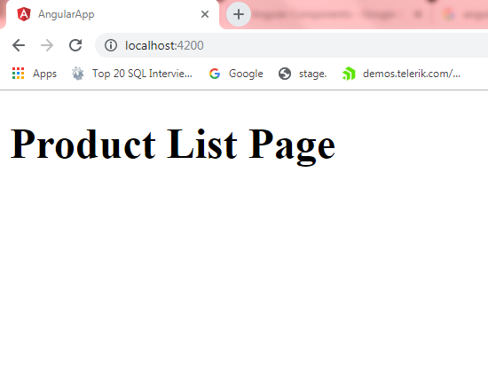

**Step 3.1.3:** Pushing the code to your GitHub repositories

* Open your command prompt and navigate to the folder where you have created your files.

**cd <folder path>**

* Initialize your repository using the following command:

**git init**

* Add all the files to your git repository using the following command:

**git add .**

* Commit the changes using the following command:

**git commit . -m “Changes have been committed.”**

* Push the files to the folder you initially created using the following command:

**git push -u origin master**